Module B.2: More Arduino Projects

**Level 0 :**

1. Super quick proof of concept of an **LED** strip controlled by an Arduino Nano, controlled by a knob on a pot which is sampled by the Arduino.
2. A) The for Loop is used for the repetition of codes and execute them. A method of handling data, so that it can be accessed easily.

B) When the condition becomes false it ends.

C) The major difference between for and while loop is at pragmatic level because under the hood, both loops are all the same conditional.

1. A **comparator** is a device that compares two voltages or currents and outputs a digital signal indicating which is larger. It has two analog input terminals and one binary digital output .

A)

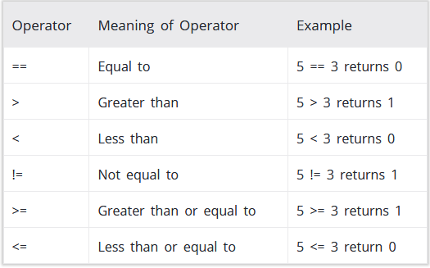

1. Done
2. The increment operator increments its operand by 1. The increment operator can appear before or after its operand.
3. Add 1 to the value.
4. Done